**P4 - Information Systems**

**What is an Information System?**An information system is a combination of IT and human resources that can perform functions using information within an organisation. They are able to store, compute, distribute and communicate information required by that organisation. A Management Information System (MIS) is a specific way of managing information in an organisation.An IT firm needs to know what the features and functions of an information system are, in order to use an information system correctly. There are five main features of a standard information system: data, people, hardware, software and telecommunications.

**People**People are another feature of an information system. They are used for finding data that the company needs for their information system. People are usually better at finding sources of information than computers, but they are more prone to making mistakes when putting the information into the system.

**Data**Data is the main form of input for an information system and is used to produce information that the company will use. When given to a system, data should be stored in the most efficient and logical way – such as organising it by related information or its source.  
The data must accurate, valid and fit-for-purpose so that when it is turned into information, the information that is used is correct and won’t result in mistakes. Giving information in an easily human-readable format is not always necessary, as it needs more processing and can take longer.

**Software**Software is one of the main components when building an information system – it is used to input, store and process data in the system. The software used will again depend on the size of the company and the purpose of the information system. There are three types of software that can be used: general-purpose, special-purpose and bespoke. Small and simple management information systems can be made using general-purpose application software that has already been programmed. Special-purpose and bespoke software can be used to build more complex management information systems for bigger companies. Cheaper special-purpose software will provide functions for a small number of PC’s whereas more expensive, bespoke software will provide functionality for a large number of computers with high performance and many features that will run the information system effectively.

**Hardware**Hardware is a feature of an information system as it is needed to run the system. The type of hardware (e.g. PC or server) that the management information system (MIS) is run on depends on how big or small the company is. If it is a large company, then a server will be needed to host the IMS so that it can cope with the amount of data being processed and stored on the device. A smaller company would use a PC, or even just write things down (for example, a small shops finances). Not only will a large processing and storage capacity be needed for large companies, but also the hardware will have to be modern and up-to-date so that the MIS runs effectively.

**Telecommunications**When information is produced, it often needs to be distributed to others around the company – telecommunication is how this takes place. Most information is shared between different departments in a company over the internet – although this can cause multiple security issues and can breach the Data Protection Act. This issue is often resolved by companies as they have an intranet where they can transfer data between departments and be protected by the company’s security system. Overall, the telecommunication system must be effective to transfer data safely and reliably. They also usually have a user policy to keep them secure and avoid wasting bandwidth.

**Functions**There are four functions of an information system: input, storage, processing and output. These functions are often enclosed in a control or feedback loop which allows the input of a system to be changed if the system output may affect it in the future. An information can either be open or closed and this affects how an IS will output information.

**Input**Input is the data that is entered into the information system and there are two types: detailed data and the form of analysis. Detailed data is where data is entered into the system to be stored and processed forming an idea for the output. The user then has to select how the system interprets and analyses the information – this depends on the purpose of the information and can be predefined by the company’s systems administrator.

**Storage**Storage is a major part of an information system. All data and information must be stored in the most detailed way possible that the system can provide. IT department of a company may choose to store summarise of data so that that data is easy to use and is consistent – thus when it is used it is more reliable. Regular backups of data should be made and copies of paper documents should be stored somewhere safe and secure in another location to protect the data/information from loss in a disaster.

**Processing**Processing converts the data into the information needed by the user. There are a wide range of ways in which data can be processed, some simple some complex. Simple processing can be something easy such as calculating sales figures for a specific criteria (e.g. time, day season). More complex processing is where a program within the information system executes complex calculations and can determine what data to use etc. Overall, processing takes raw data inputted into the system and uses it to produce information suitable to the user’s purpose for it.

**Output**Like input, there are two ways to output information in an information system – graphical and textual. Graphical outputs are used to represent information in a way in which the user can see the ‘big picture’. Graphical output makes it easier to understand trends in a company and can be used to highlight changes in the company (e.g. a drop in sales). It is most commonly used when presenting data to management as it is easier to follow. Textual outputs represent information using text and numbers. This method of outputting data is used when the user must analyse detail and know specific information. Both formats can be used collectively to represent information – graphical outputs can show important figures as a whole and textual outputs can be used to go into more detail on a specific area etc.

**Control and Feedback Loops**Control or feedback loops determine how future inputs into the system are affected by the current output of the information system. The effect on the input may be direct or indirect; a feedback loop will analyse the system output and if necessary, it adjusts the system’s performance to produce the user’s desired outcome. The diagram below shows how the feedback loop works.

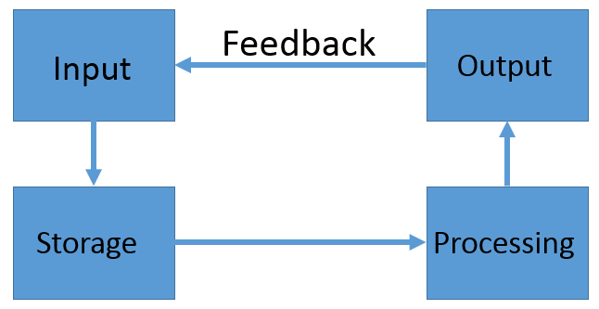

**Closed and Open Systems**There are two types of information system: closed and open. Closed systems have a fixed setoff outputs. Typically, the user can only chose between a few select formats in which information is outputted. This system is easy to use and is aimed at presenting information to management. Open systems give the user a wide variety of options in which they can present their information. This type of system often requires users with expertise using them as the various options available can mean the system is not always used effectively. This is why the system is aimed at analysts in a company as they require information in a variety of formats – thus it gives both graphical and textual outputs.